INTERNSHIP REPORT
Name | Tharunya Manokaran
Name of the Internship | Infosys Springboard virtual Internship 7.0
Title | AI-Driven Cognitive  Wake- Up Platform for Personalized Challenges and Habit Formation

Table of Contents
Chapter No. | Contents | Page No.
1 | Introduction to Cognitive Wake-up Alarm | 4
 | i. Overview
 | ii. Introduction
 | iii. Features
 | iv. Applications
 | v. Benefits
2 | Objectives of the Internship | 6
 | i. Learning Objectives
 | ii. Technical Objectives
 | iii. Career Development Objectives
3 | System Architecture | 7
 | i.Architecture Used
 | ii. Components
 | iii. Architecture Flowchart
4 | Internship Activities and Learning Experience | 8
 | i. Daily Activities Performed
 | ii. Tasks Completed During Internship
 | iii. Skills Acquired
 | iv. Challenges Faced and Solutions
5 | Project Work | 10
 | i. Project Overview Tasks
 | ii. Business Requirement Analysis
 | iii. Implementation Process
 | iv. Results and Outcomes
6 | Deployment Process | 23
7 | Learning Outcomes and Conclusion | 24

CHAPTER – 1
Introduction to CognitiveWake-Up Alarm

1.1. Overview
CognitiveWake is an AI-based cognitive alarm platform designed to make waking up more interactive and effective. Unlike traditional alarm systems, it requires users to complete a cognitive challenge before dismissing the alarm. The system includes personalized alarm settings, brain exercises, habit score tracking, and streak monitoring. It aims to encourage users to develop consistent waking habits and improve their morning routines through an engaging and user-friendly interface.
1.2. Introduction
Waking up on time is a common challenge for students, working professionals, and individuals with busy schedules. Traditional alarm clocks can be dismissed easily, which may encourage repeated snoozing and irregular waking habits. CognitiveWake addresses this problem by introducing cognitive challenges such as mathematical problems, memory exercises, and pattern recognition tasks. Users must complete the assigned challenge to turn off the alarm. The platform also tracks user progress through habit scores and streaks, encouraging consistency and helping users maintain a structured daily routine.
1.3. Features
CognitiveWake provides several features to improve the alarm experience and encourage consistent waking habits. It includes user registration and login, customizable alarm management, interactive cognitive challenges, and multiple difficulty levels. The platform also provides a personalized dashboard where users can monitor their habit scores and streaks.
Role-based access supports different permissions for users, moderators, and administrators. Additionally, the responsive interface allows users to access the platform conveniently across desktops, tablets, and mobile devices.

1.4. Applications
CognitiveWake can be used by students, working professionals, and individuals who want to establish a consistent morning routine. Students can use the platform to wake up on time for classes, examinations, and other academic activities. Working professionals can incorporate it into their daily schedules to improve punctuality. The cognitive challenges provide short mental activities that engage users when responding to the alarm. The platform can also support personal habit development by tracking waking consistency and encouraging users to maintain regular schedules.
1.5. Benefits
CognitiveWake offers several benefits compared with traditional alarm systems. By requiring users to complete a cognitive challenge, it discourages the simple dismissal of alarms without interaction. The interactive tasks encourage active engagement upon waking, while habit scores and streak tracking help users monitor their progress. Personalized alarm settings and adjustable challenge difficulties improve flexibility and user convenience. The platform combines alarm management, cognitive activities, and habit tracking in a single system, providing an engaging approach to developing consistent morning routines.

CHAPTER – 2
Objectives of the internship
2.1. Learning Objectives
The primary learning objective of the CognitiveWake project is to understand how intelligent applications can be developed to address real-world problems. This project provides an opportunity to learn about cognitive challenges, alarm management, user interaction, and habit tracking. It also helps improve problem-solving abilities, logical thinking, and the practical application of theoretical concepts in software development.
2.2. Technical Objectives
The technical objective of CognitiveWake is to develop a user-friendly and responsive alarm platform that requires users to complete cognitive challenges before dismissing alarms. The project focuses on implementing features such as user authentication, alarm scheduling, interactive challenges, habit score tracking, and streak monitoring. It also aims to strengthen knowledge of frontend development, backend integration, database management, and application deployment while providing a smooth user experience across different devices.
2.3. Career Development Objectives
The career development objective of this project is to gain practical experience in software development and understand the process of building and deploying a complete application. It helps develop technical skills, analytical thinking, creativity, and problem-solving abilities. Working on CognitiveWake also improves project management, debugging, and independent learning skills, which are valuable for future internships, academic projects, and professional opportunities in the software development and technology industries.

CHAPTER – 3
System Architecture
3.1. Architecture Used
CognitiveWake follows a three-tier architecture consisting of the Presentation Layer, Application Layer, and Data Layer. The Presentation Layer provides the user interface, the Application Layer handles the system's core functionalities, and the Data Layer manages data storage and retrieval. These layers work together to provide efficient communication between the user interface, backend services, and database, ensuring a maintainable and responsive application.
3.2. Components
The major components of CognitiveWake include the User Authentication Component for registration and login, the Alarm Management Component for creating and managing alarms, the Cognitive Challenge Component for providing interactive brain exercises, and the Habit Tracking Component for monitoring habit scores and waking streaks. The Role-Based Access Component manages permissions for users, moderators, and administrators. The API Integration Component enables communication between the frontend and backend, while the Database Management Component uses MongoDB to store and retrieve user information, alarm configurations, challenge details, and progress records.
3.3. Architecture flow
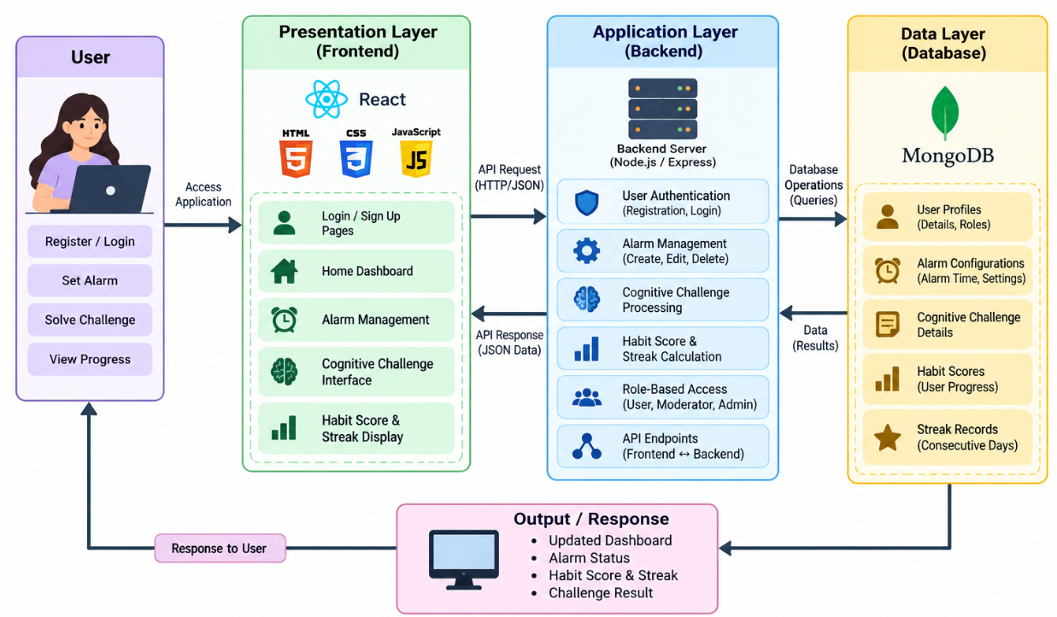
CHAPTER – 4
Internship Activities and Learning Experience
i. Daily Activities Performed
During the development of the CognitiveWake platform, daily activities included understanding project requirements, designing the user interface, developing application features, and testing their functionality. The work involved creating login and registration pages, developing the dashboard, implementing alarm management, and designing interactive cognitive challenges. Additional activities included integrating the frontend with the backend, managing user data, improving the responsive design for mobile devices, and checking the overall performance of the application. Regular testing and debugging were performed to identify errors and improve the user experience.
ii. Tasks Completed During Internship
During the internship, the CognitiveWake platform was developed as an interactive alarm management application. The major tasks completed included designing the user interface using React, HTML, CSS, and JavaScript, implementing user authentication, and developing alarm management functionality. Cognitive challenges were incorporated to require users to complete simple brain exercises before dismissing alarms. Habit score and streak tracking features were also developed to monitor user progress. Backend integration and MongoDB database management were used to handle application data. The application interface was optimized for mobile devices, and deployment was carried out using Render to make the platform accessible online.
iii. Skills Acquired
The development of CognitiveWake helped improve technical and professional skills. Technical skills acquired included frontend development using React, HTML, CSS, and JavaScript, understanding backend API integration, database management using MongoDB, and application deployment using Render. Practical experience was gained in implementing user authentication, managing application data, developing interactive features, and debugging software errors. The project also improved problem-solving, logical thinking, time management, independent learning, and project development skills.
iv. Challenges Faced and Solutions
During the development of CognitiveWake, several challenges were encountered, including connecting the frontend with the backend, managing user authentication, ensuring that application features worked correctly, and resolving deployment issues. Another challenge was making the platform responsive across desktop and mobile devices. These issues were addressed by checking API configurations, testing application functionality, debugging code, and modifying CSS styles to improve responsiveness. Deployment-related problems were investigated by checking the latest code changes, GitHub updates, and Render deployment status. Through these solutions, the application became more user-friendly, responsive, and reliable.

CHAPTER – 5
Project Work

5.1. Project Overview
CognitiveWake is an AI-based cognitive alarm platform designed to encourage users to wake up actively and maintain consistent morning routines. Unlike traditional alarm systems, which can be dismissed with a single tap, CognitiveWake requires users to complete a cognitive challenge before turning off the alarm. The platform provides features such as user authentication, alarm management, interactive brain exercises, habit score tracking, and streak monitoring. The application uses React for the frontend, backend APIs for application logic, and MongoDB for data storage. It also provides a responsive interface for convenient access across desktop and mobile devices. The primary goal of the project is to make waking up more interactive and encourage users to develop regular waking habits.

5.2. Business Requirement Analysis
The business requirement analysis identifies the problems associated with traditional alarm systems and determines the features required to address them. Many users struggle to wake up on time because conventional alarms can be stopped easily without meaningful interaction. Therefore, CognitiveWake aims to provide a more engaging alarm experience through cognitive challenges and progress tracking. The functional requirements include user registration and login, alarm creation and management, cognitive challenge execution, habit score calculation, streak tracking, and role-based access control. The non-functional requirements include a user-friendly interface, responsive design, reliable data storage, secure authentication, and efficient application performance. The system is designed for students, working professionals, and individuals who want to improve their morning routines. These requirements guide the development of a practical and accessible cognitive alarm platform.

5.3. Implementation Process
The implementation of CognitiveWake was carried out through several development stages. Initially, the project requirements were analyzed, and the application architecture and user interface were planned. The frontend was developed using React, HTML, CSS, and JavaScript to create the login page, dashboard, alarm management interface, and cognitive challenge screens. The backend APIs were integrated to process user requests and manage the application's core functionalities. MongoDB was used to store user profiles, alarm configurations, challenge information, and progress records. Cognitive challenge functionality was implemented to require users to solve interactive exercises before dismissing alarms. Habit score and streak tracking features were incorporated to display user progress. The application was then tested to identify and resolve functional errors, and the interface was improved to support mobile devices. Finally, the application was deployed using Render, making the platform accessible online for further testing and use.

5.4. Results and Outcomes
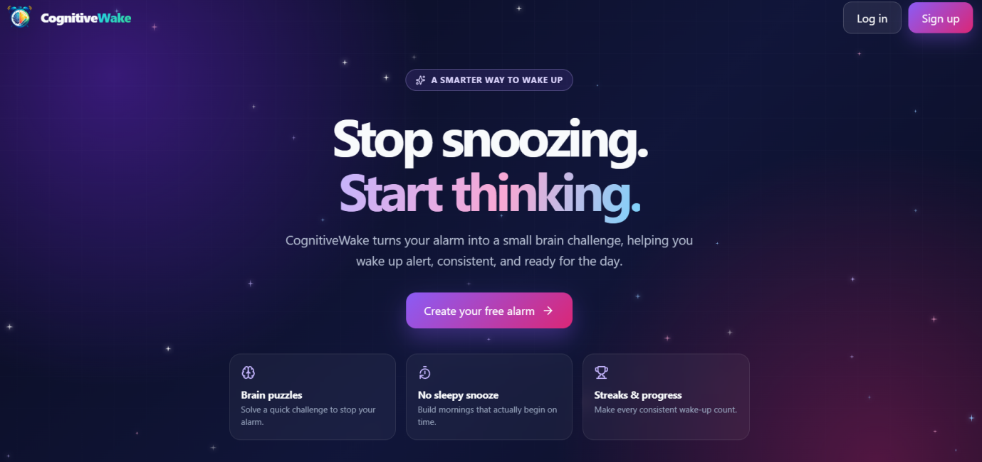
Figure 5.4.1. This figure shows the CognitiveWake homepage, featuring smart alarms, brain puzzles, and streak tracking to help users wake up actively and maintain consistent morning routines.

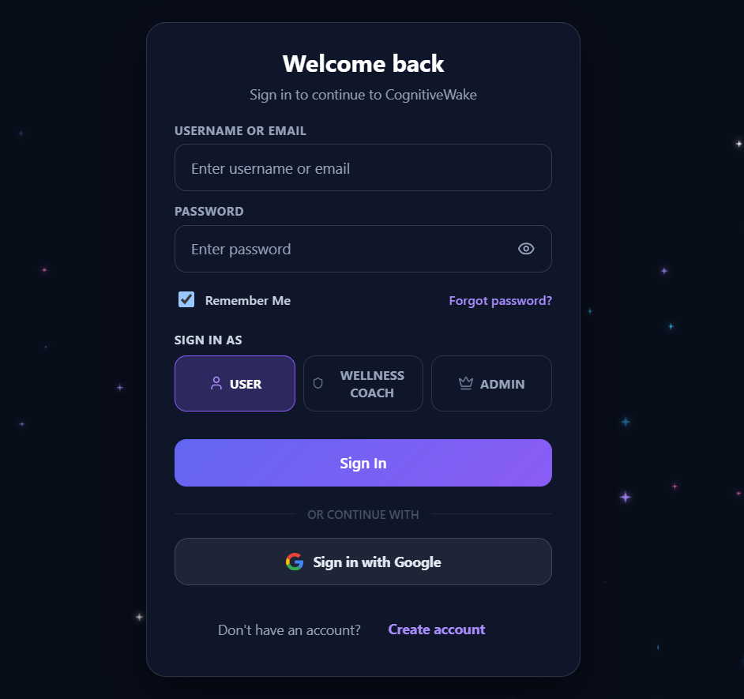
Figure 5.4.2. This figure shows the CognitiveWake Login Page, which allows users to sign in securely using their username or email and password, select their role as User, Wellness Coach, or Admin, and access the platform through Google sign-in or account creation options
. 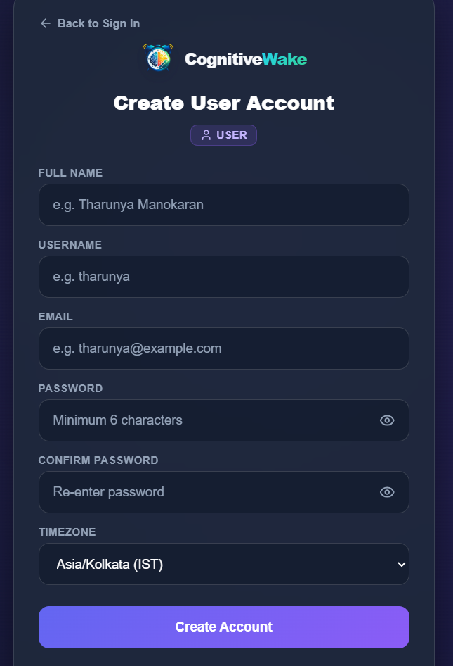
Figure 5.4.3. This figure shows the CognitiveWake User Registration Page, where new users can create an account by entering their full name, username, email address, password, and confirm password, along with selecting their preferred timezone to access the platform.
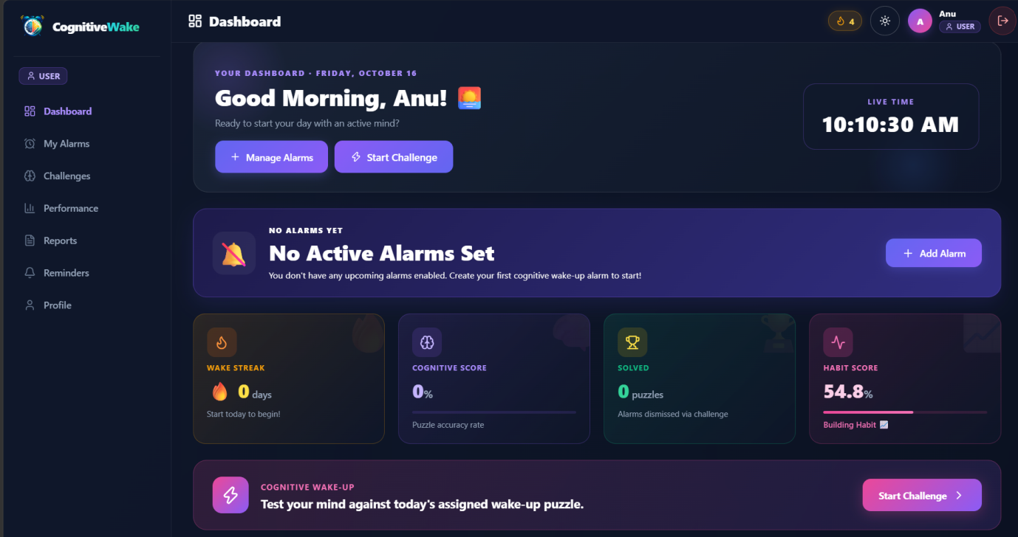
Figure 5.4.4. This figure shows the CognitiveWake User Dashboard, which displays the welcome message, live time, alarm management options, and performance metrics such as wake streak, cognitive score, solved puzzles, and habit score, allowing users to manage alarms and start cognitive challenges from a single interface.

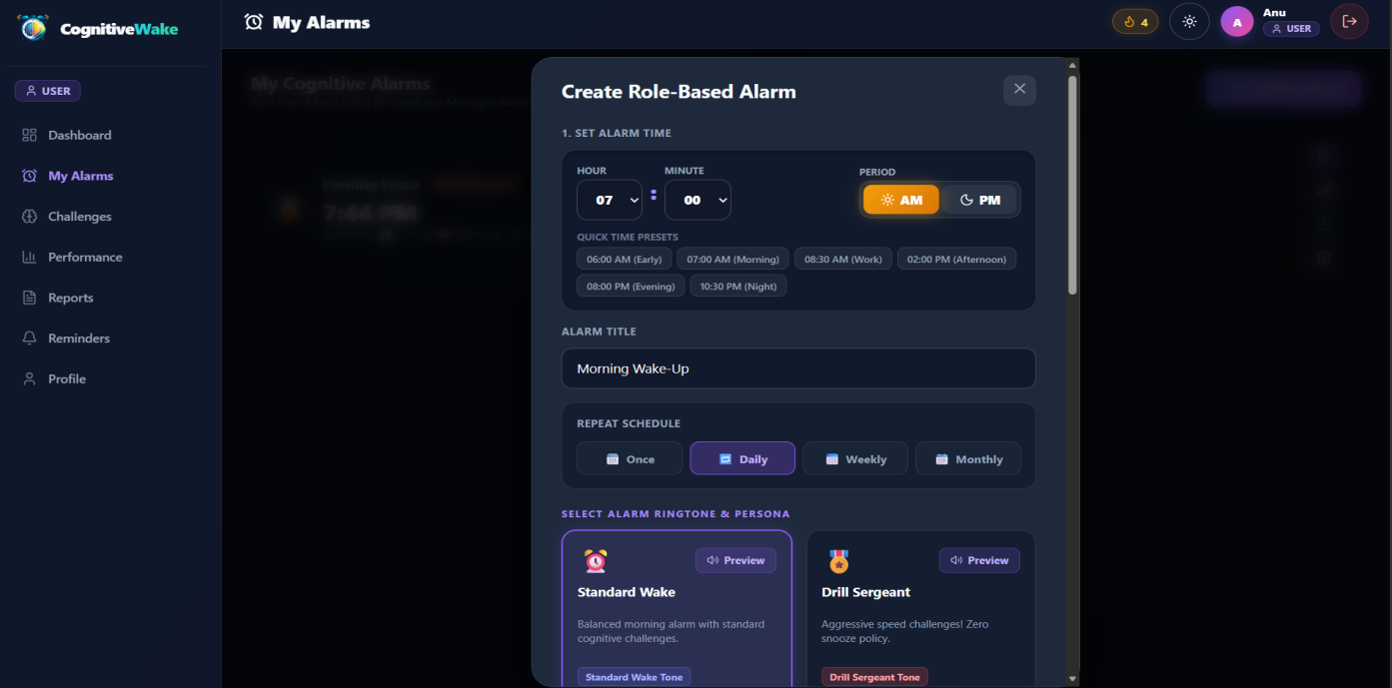
Figure 5.4.5. This figure shows the CognitiveWake Alarm Management Page, where users can set alarm times, choose repeat schedules, and customize alarm tones and wake-up styles.

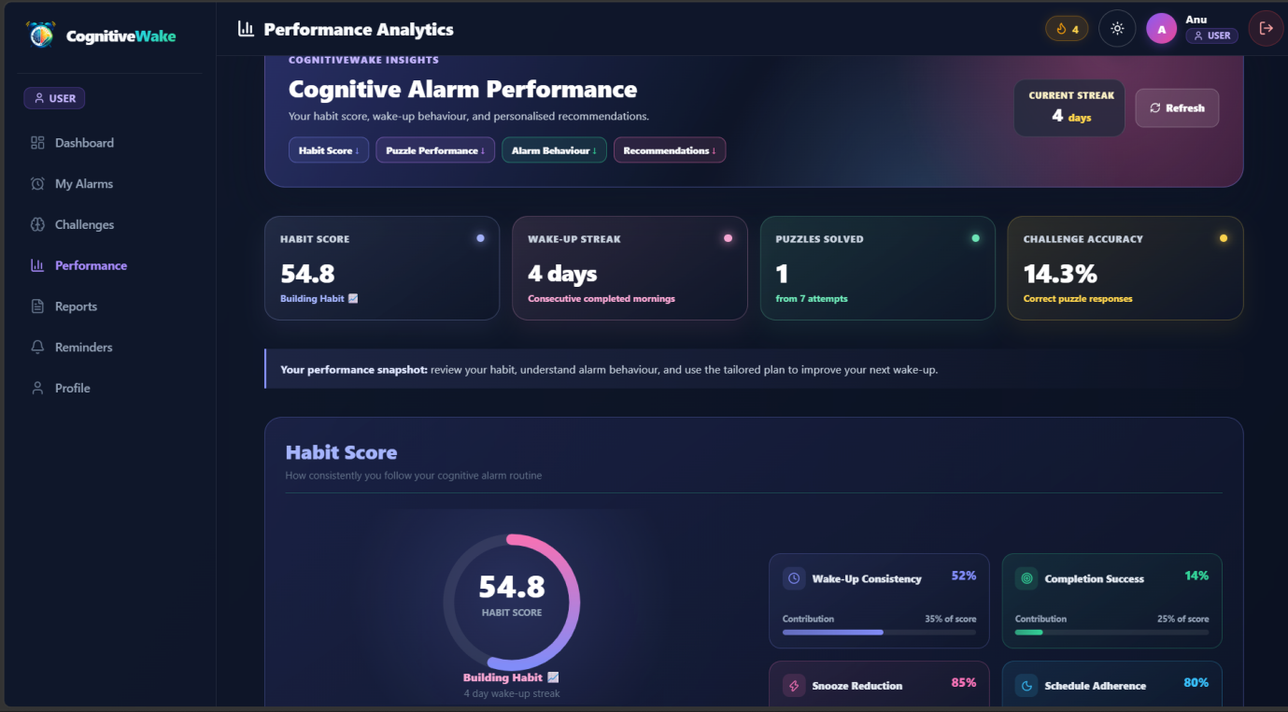
Figure 5.4.6. This figure shows the CognitiveWake Performance Analytics Page, displaying habit scores, wake-up streaks, puzzles solved, challenge accuracy, and personalized insights to help users track their progress.

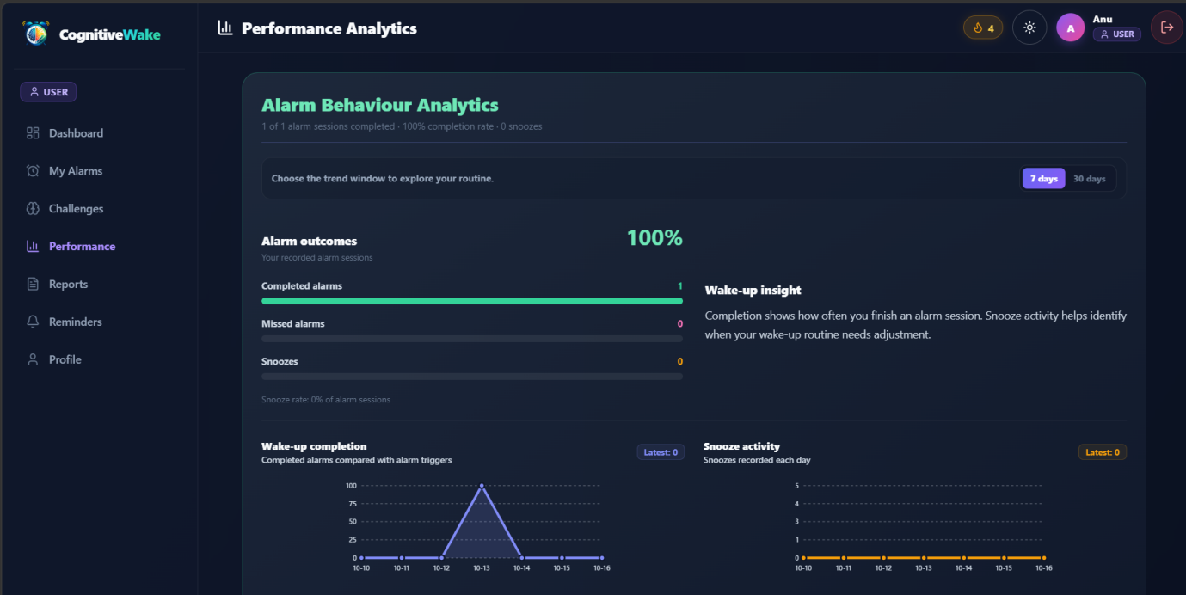
Figure 5.4.7. This figure shows the Alarm Behaviour Analytics Page, displaying completed and missed alarms, snooze activity, completion rates, and graphical trends to help users understand their waking habits.

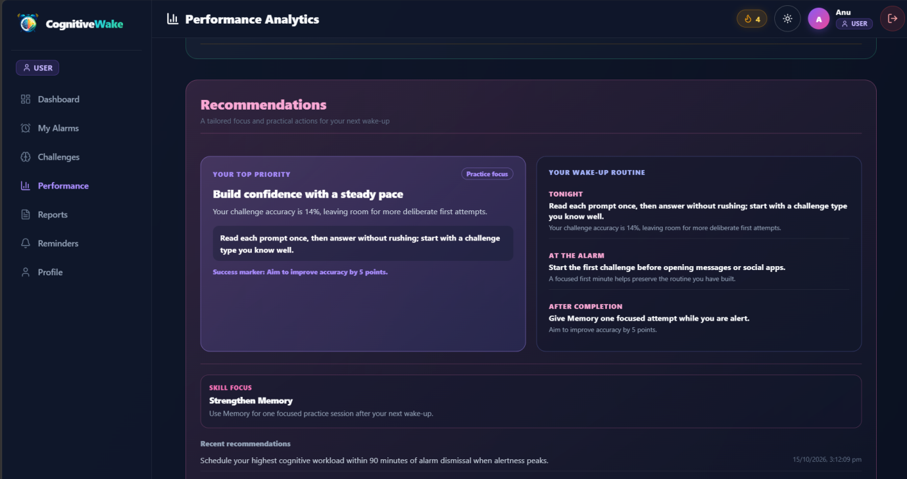
Figure 5.4.8. This figure shows the Recommendations Page, providing personalized wake-up tips, memory practice suggestions, and strategies to improve cognitive challenge accuracy and maintain consistent waking habits.

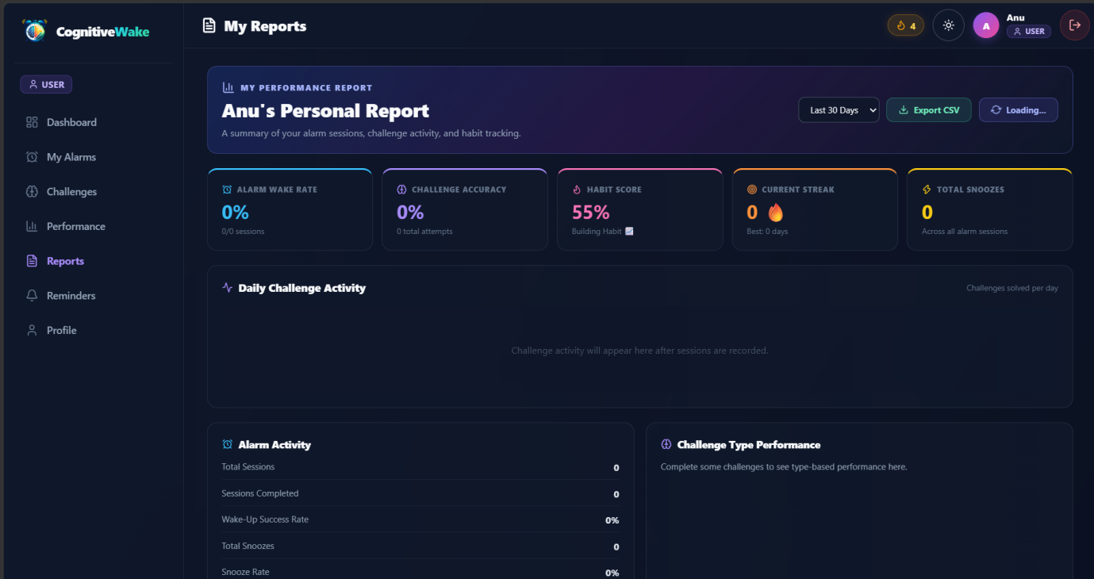
Figure 5.4.9. This figure shows the CognitiveWake Reports Page, summarizing alarm wake-up rates, challenge accuracy, habit scores, streaks, and snooze activity, with options to export performance reports as CSV files.

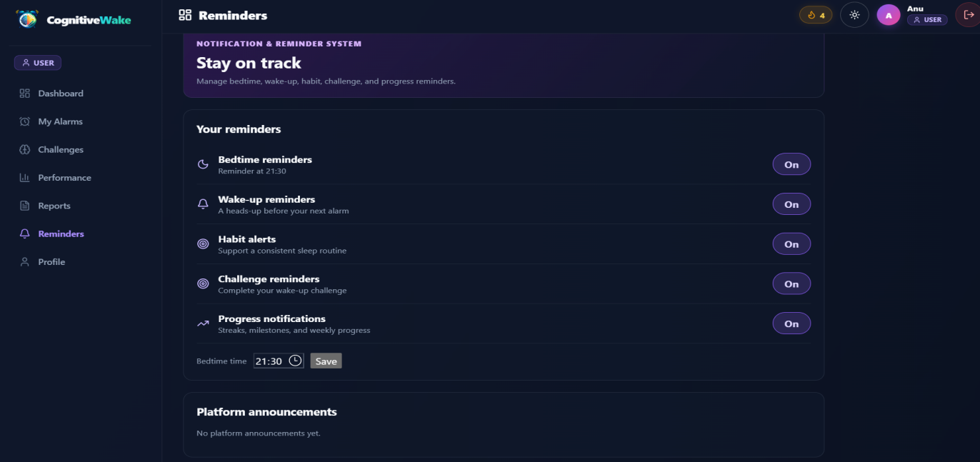
Figure 5.4.10. This figure shows the CognitiveWake Reminders Page, allowing users to manage bedtime, wake-up, habit, challenge, and progress notifications to maintain a consistent daily routine.

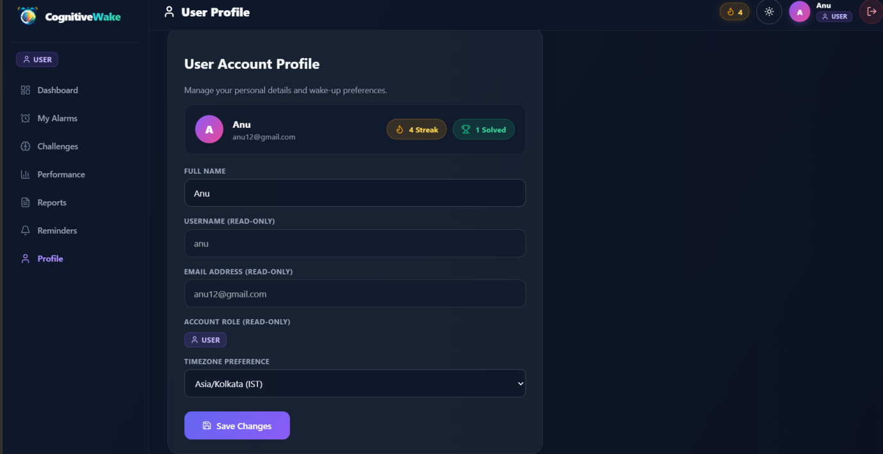
Figure 5.4.11. This figure shows the CognitiveWake User Profile Page, allowing users to view and update their personal details, manage timezone preferences, and monitor their waking streak and completed challenges.

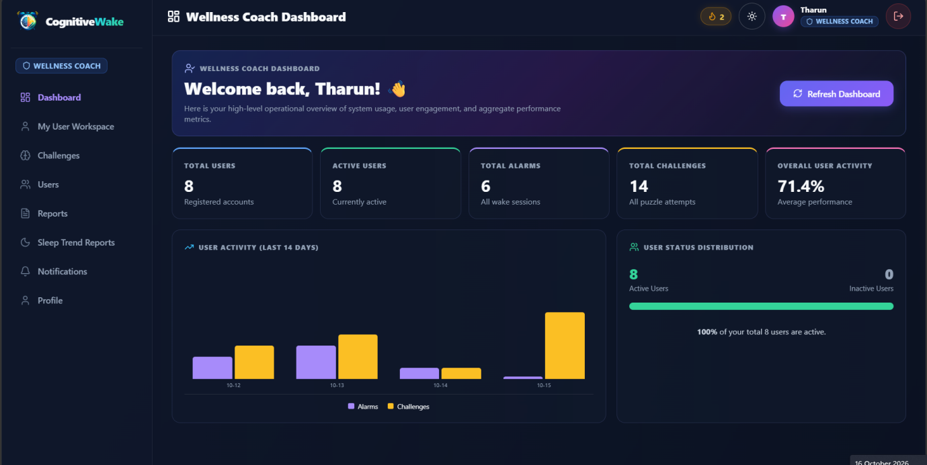
Figure 5.4.12. This figure shows the CognitiveWake Wellness Coach Dashboard, displaying total users, active users, alarms, cognitive challenges, overall user activity, and usage statistics to monitor platform performance and user engagement.

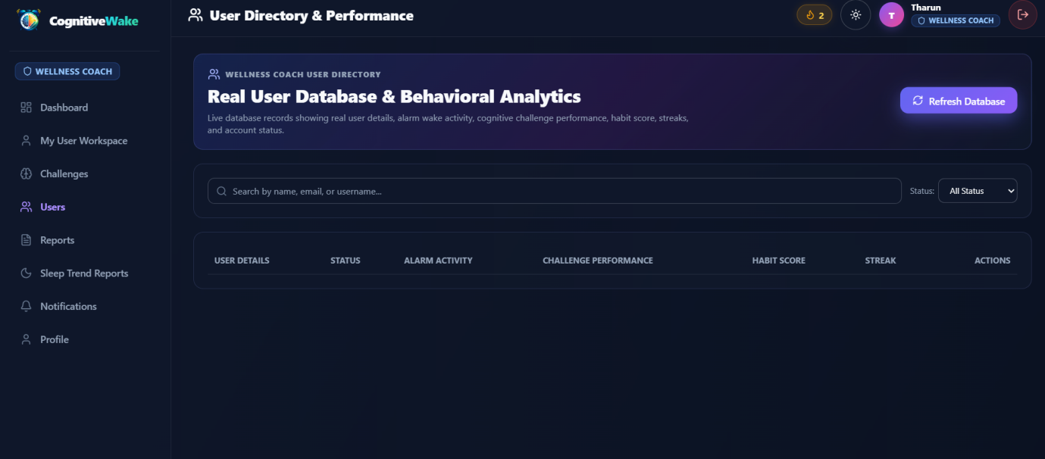
Figure 5.4.13. This figure shows the Wellness Coach User Directory, allowing coaches to search users and monitor their account status, alarm activity, cognitive challenge performance, habit scores, and waking streaks.

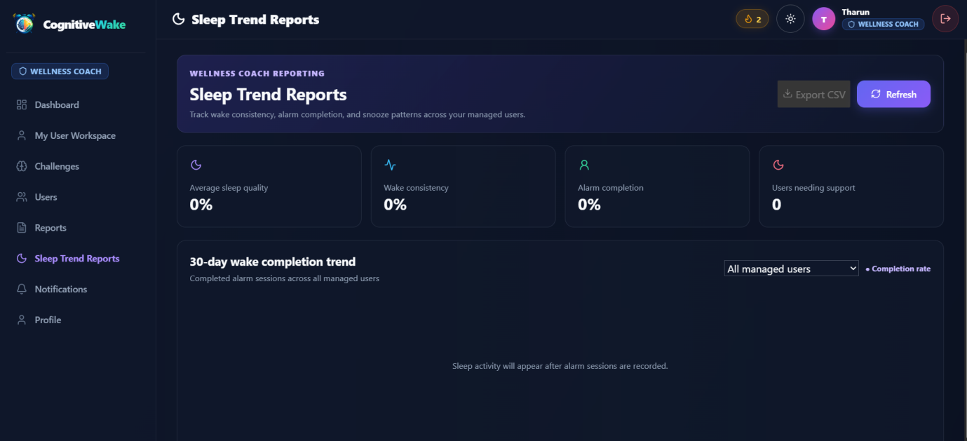
Figure 5.4.14. This figure shows the Sleep Trend Reports Page, helping wellness coaches monitor users’ sleep quality, waking consistency, alarm completion rates, and sleep-related trends over 30 days.

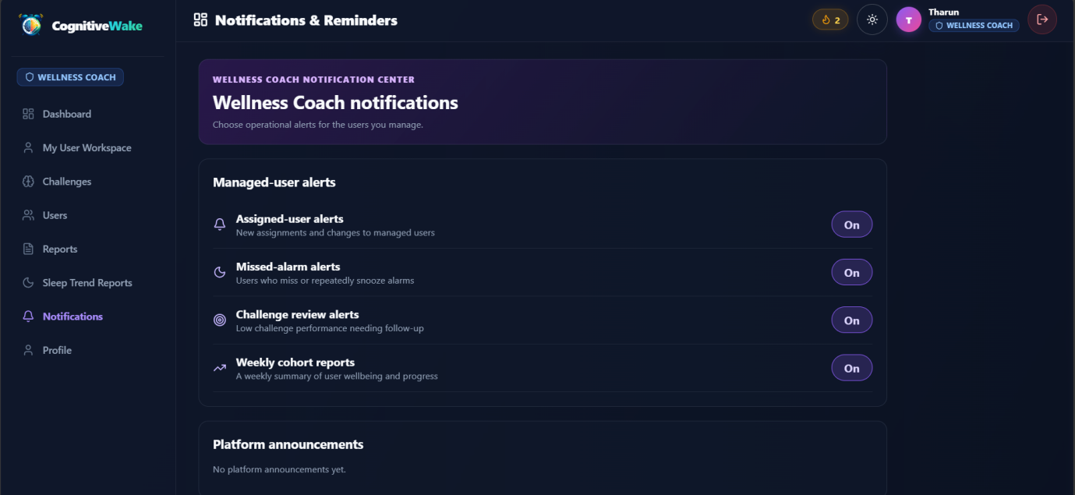
Figure 5.4.15. This figure shows the Wellness Coach Notifications Page, allowing coaches to manage alerts for user assignments, missed alarms, low challenge performance, and weekly progress reports.

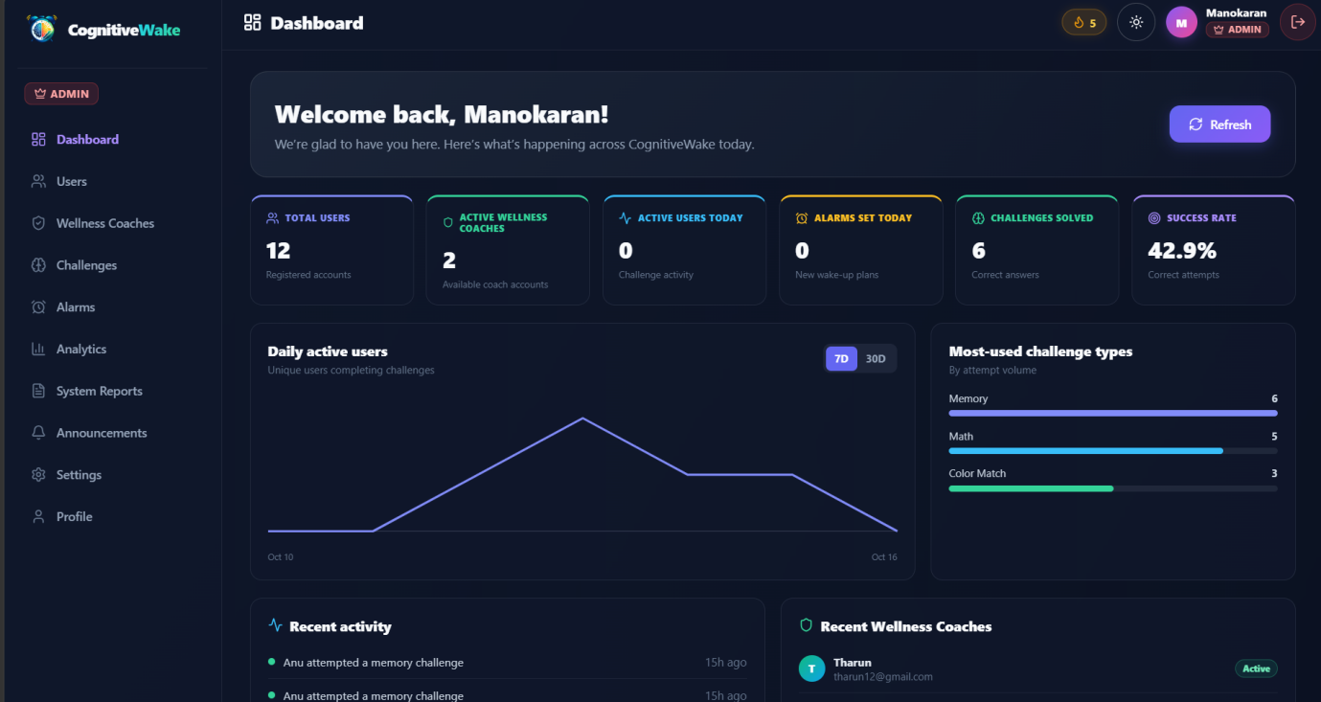
Figure 5.4.16. This figure shows the CognitiveWake Admin Dashboard, displaying total users, active wellness coaches, alarms, challenges solved, success rates, and system activity for overall platform management.

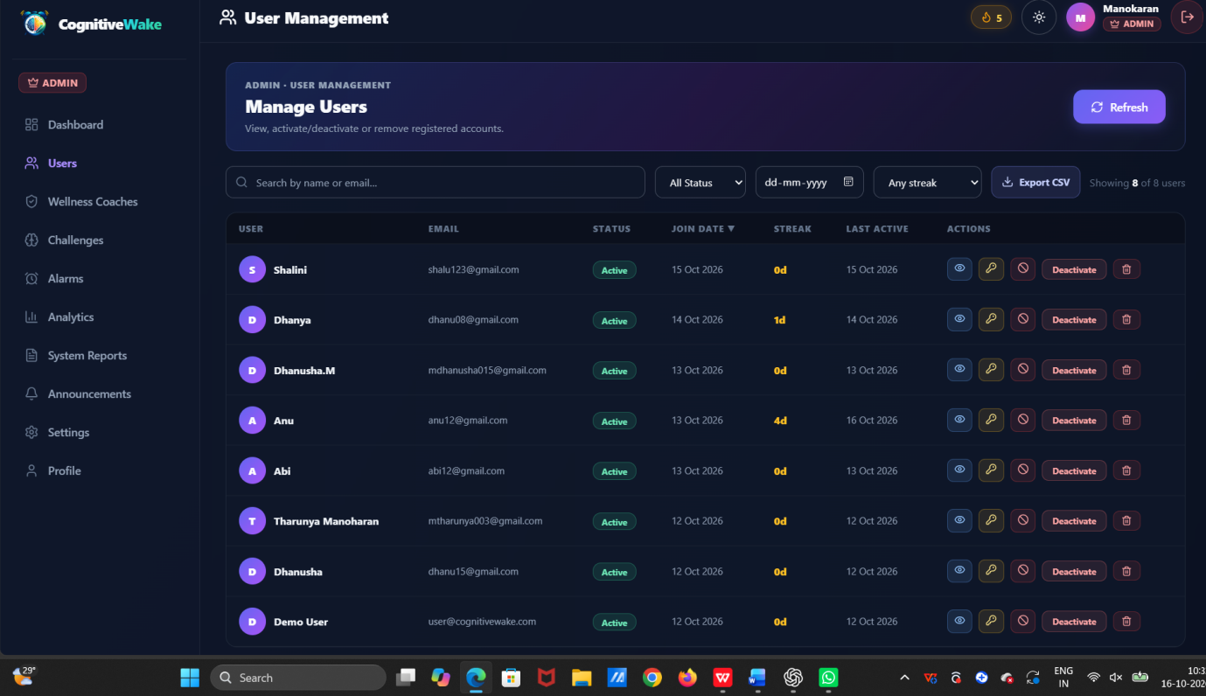
Figure 5.4.17. This figure shows the CognitiveWake Admin User Management Page, allowing administrators to search users, monitor account status and streaks, activate or deactivate accounts, and export user details as CSV files.

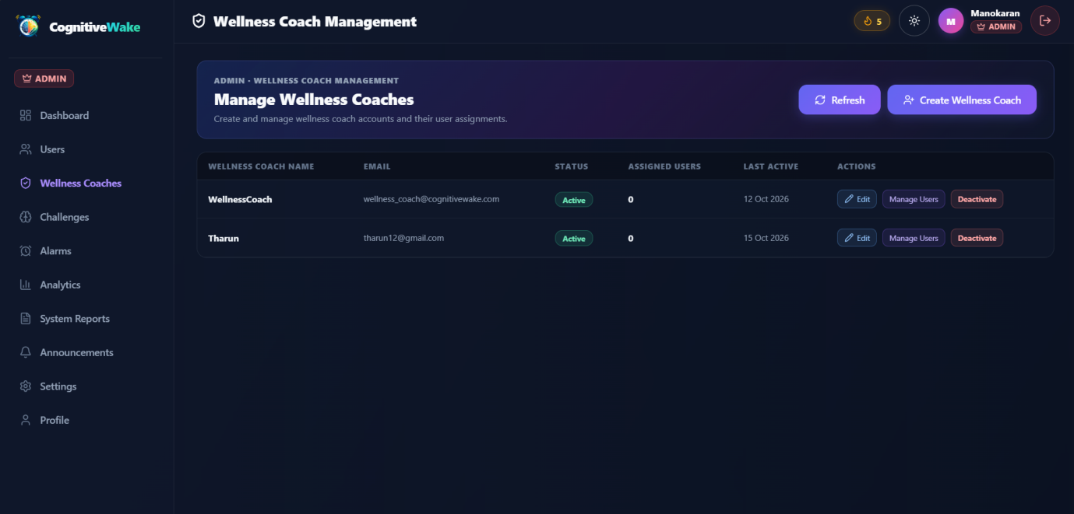
Figure 5.4.18. This figure shows the CognitiveWake Wellness Coach Management Page, allowing administrators to create, edit, activate or deactivate wellness coach accounts, and manage their assigned users.

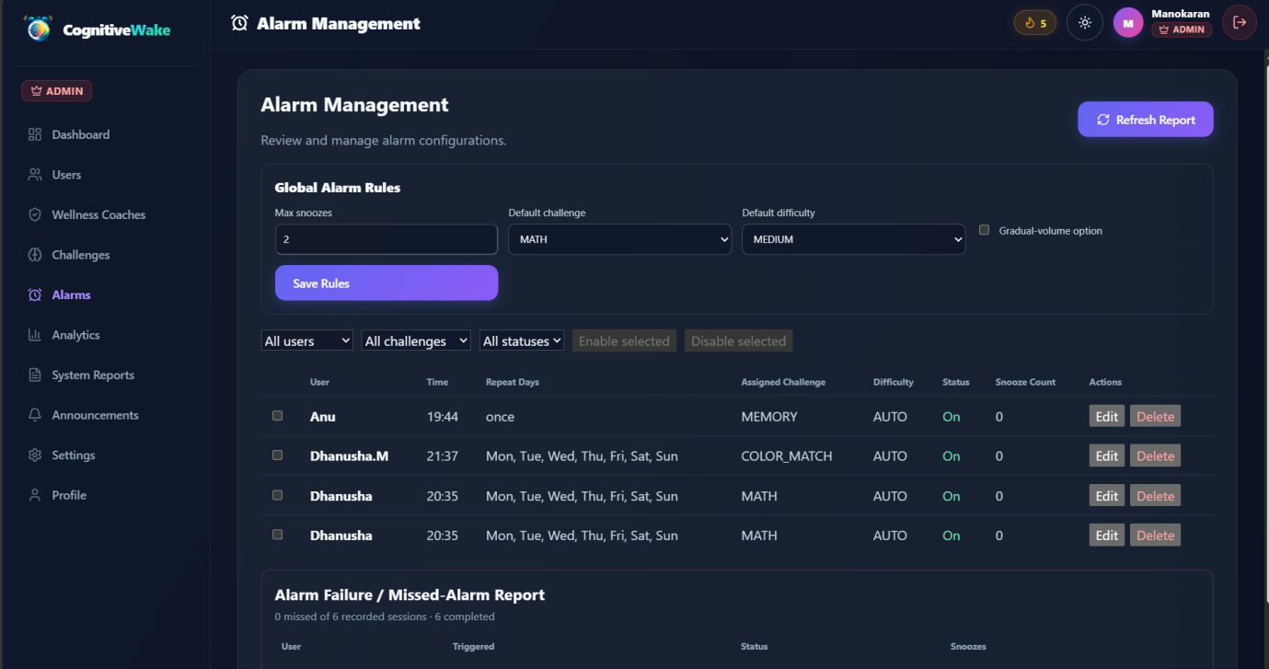
Figure 5.4.19. This figure shows the CognitiveWake Admin Alarm Management Page, allowing administrators to configure global alarm rules, manage user alarms, set challenge difficulty, and monitor missed-alarm reports.

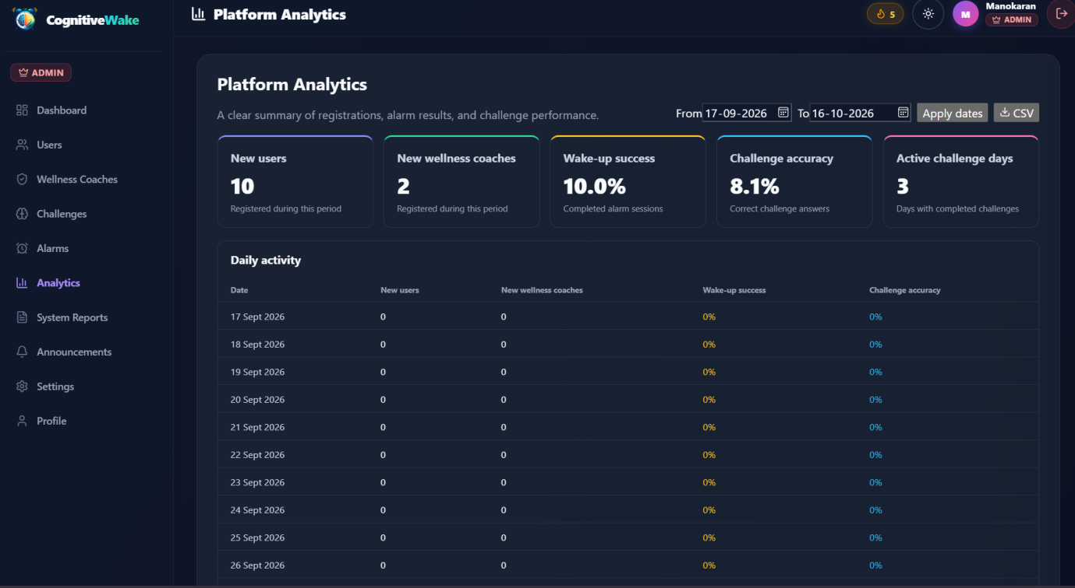
Figure 5.4.20. This figure shows the CognitiveWake Platform Analytics Page, displaying new user registrations, wellness coaches, wake-up success rates, challenge accuracy, and daily activity statistics.

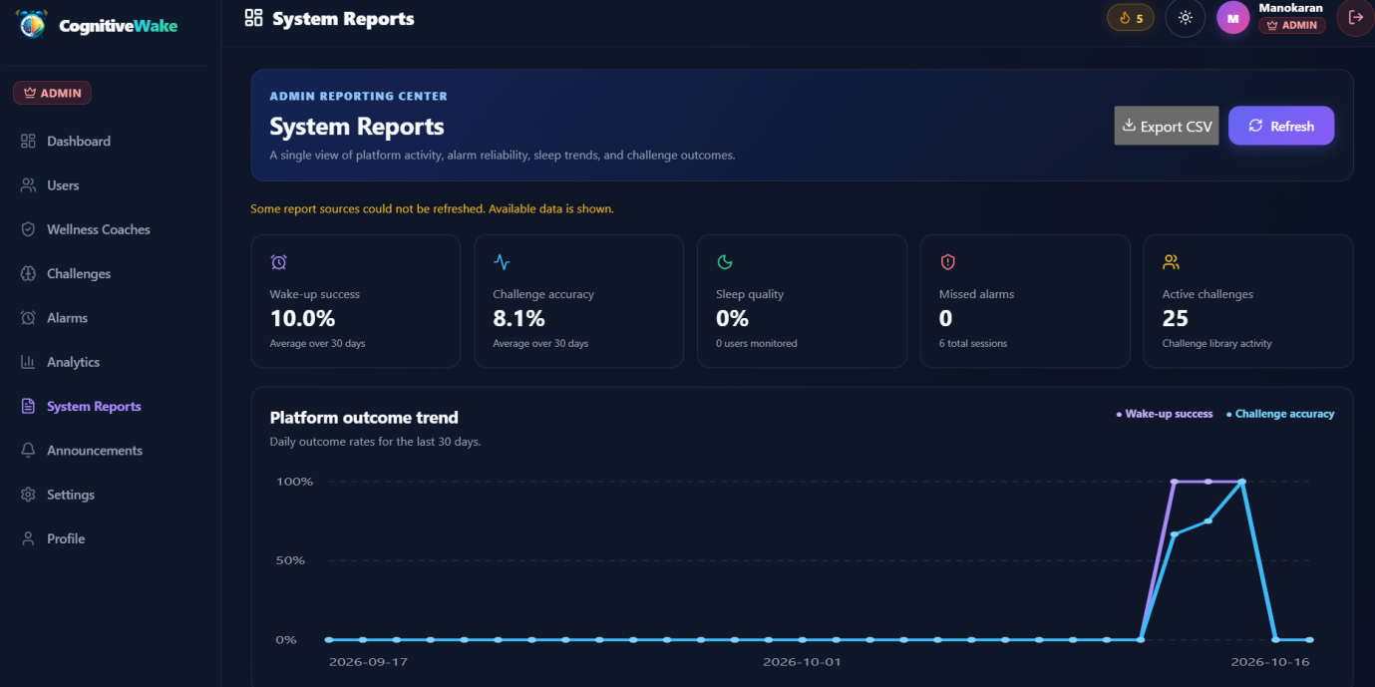
Figure 5.4.21. This figure shows the CognitiveWake System Reports Page, displaying wake-up success rates, challenge accuracy, sleep quality, missed alarms, and platform performance trends for administrators.

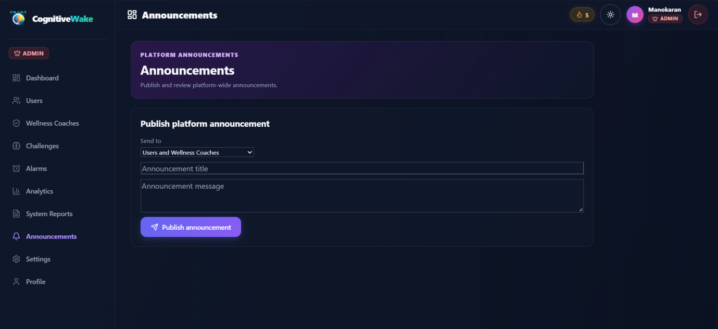
Figure 5.4.22. This figure shows the CognitiveWake Admin Announcements Page, allowing administrators to publish platform-wide announcements and share important updates with users and wellness coaches.

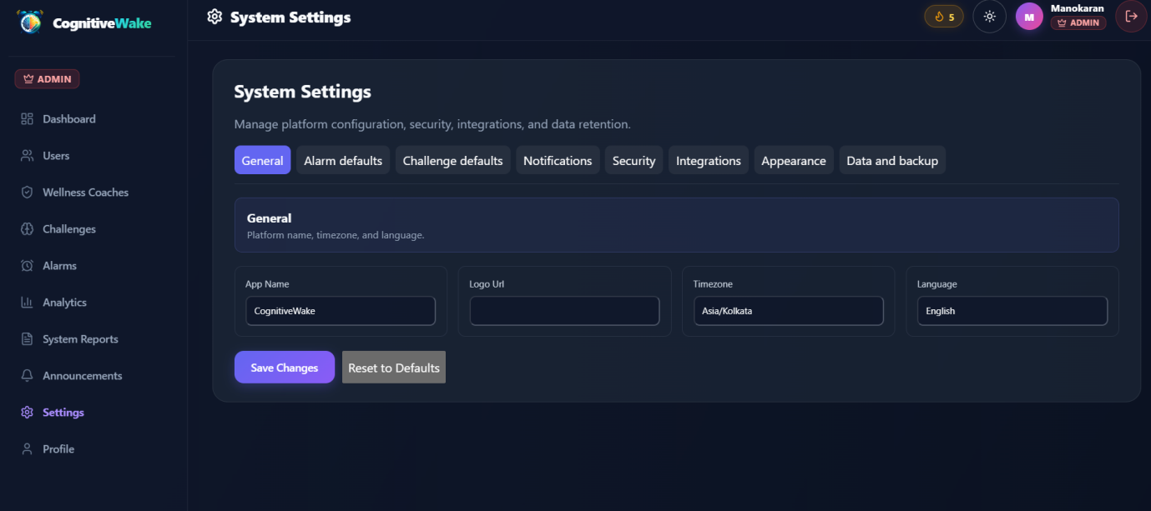
Figure 5.4.23. This page shows the CognitiveWake Admin System Settings, where the administrator can configure the platform name, logo URL, timezone, language, alarm defaults, challenge settings, security, notifications, and data backup. The Save Changes button saves the updated settings, while Reset to Defaults restores the default configuration.

CHAPTER – 6
Deployment
The CognitiveWake – AI Cognitive Alarm Platform was deployed using Docker and Docker Compose to simplify application setup and service management. Initially, the frontend, backend, and database configurations were prepared for deployment. The frontend was developed using React and Vite, while the backend was developed using FastAPI and Uvicorn. MongoDB was integrated to store user information, alarm configurations, cognitive challenge records, and habit tracking data. Docker was used to containerize the application components, while Docker Compose was used to configure and manage the frontend, backend, and MongoDB services together. The application was built and started using the docker compose up --build command, which built the required images and launched the configured containers. After deployment, the application was tested to verify user authentication, alarm management, cognitive challenges, dashboard functionality, and database connectivity. This deployment process simplified environment configuration, improved consistency across services, and made the application easier to run and maintain.

CHAPTER – 7
Learning Outcomes and Conclusions
Through the development of the CognitiveWake – AI Cognitive Alarm Platform, we gained practical knowledge of full-stack web development, including frontend design using React, HTML, CSS, and JavaScript, backend integration through APIs, and database management using MongoDB. We learned to implement important features such as user authentication, alarm management, interactive cognitive challenges, habit score tracking, streak monitoring, and role-based access for users, wellness coaches, and administrators. We also gained experience in application testing, debugging, responsive web design, version control using GitHub, and deployment using Render. This project helped us improve our technical knowledge, logical thinking, problem-solving abilities, and understanding of real-world software development. In conclusion, CognitiveWake provides an interactive approach to traditional alarm management by requiring users to complete cognitive challenges before dismissing alarms. With features such as personalized alarms, performance analytics, and habit tracking, the platform encourages users to maintain consistent waking routines. Overall, this project strengthened our practical development skills and provided valuable experience in designing, developing, testing, and deploying a complete web application.

